**CSE3506 – ESSENTIALS OF DATA ANALYTICS**

**EXPT NO: 1**

**DATE:** 2/3/2021

**NAME:** R. Harini

**REG. NO.:** 18BCE1010

**REGRESSION**

**AIM**

To perform the following: (i) simple linear regression and (ii) multi linear regression

**MATLAB PROGRAM**

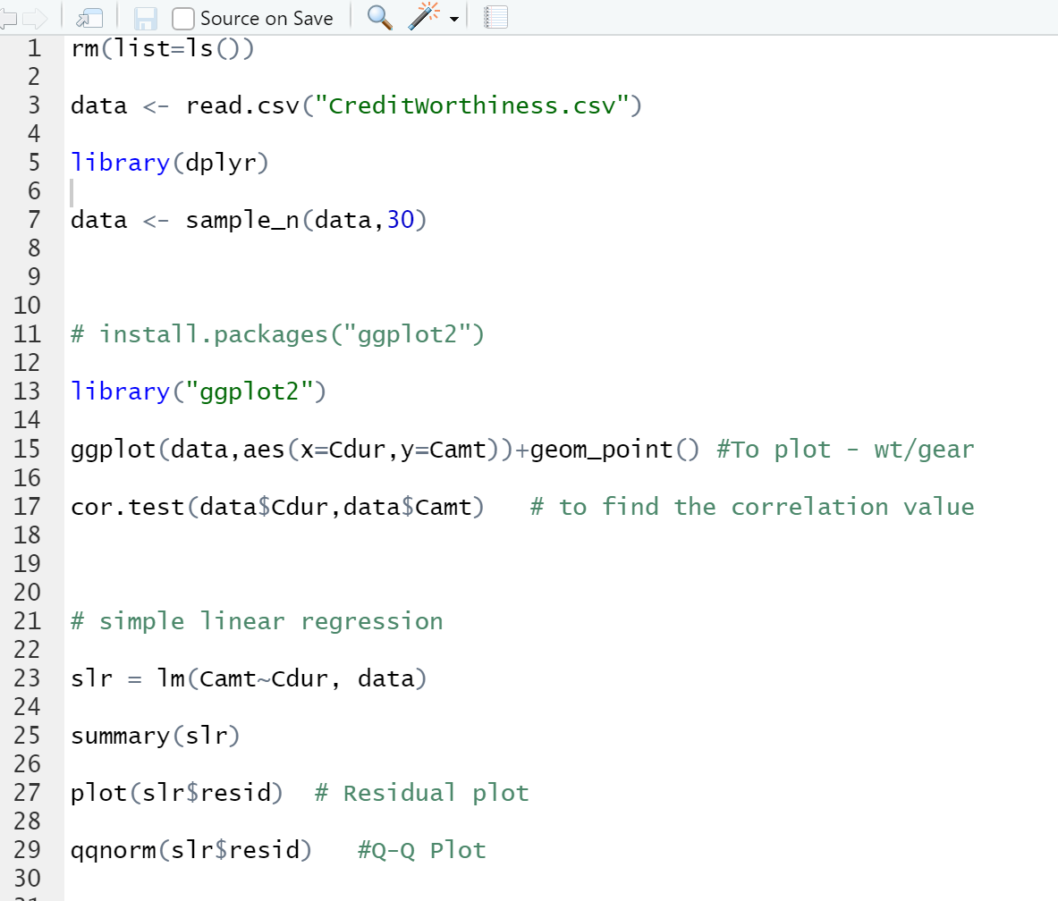

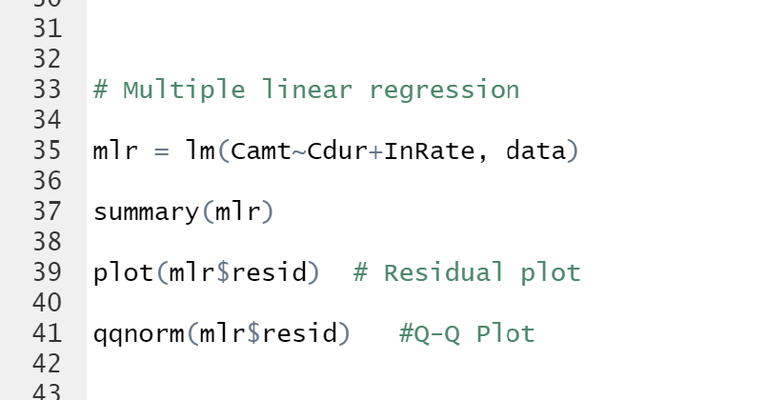

**OUTPUT**

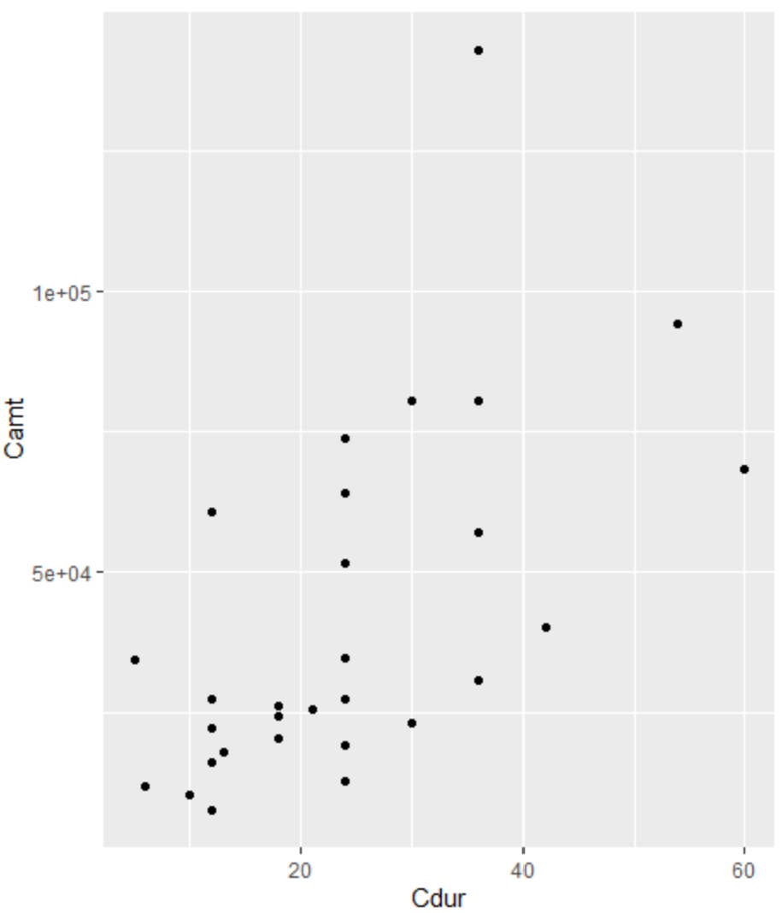 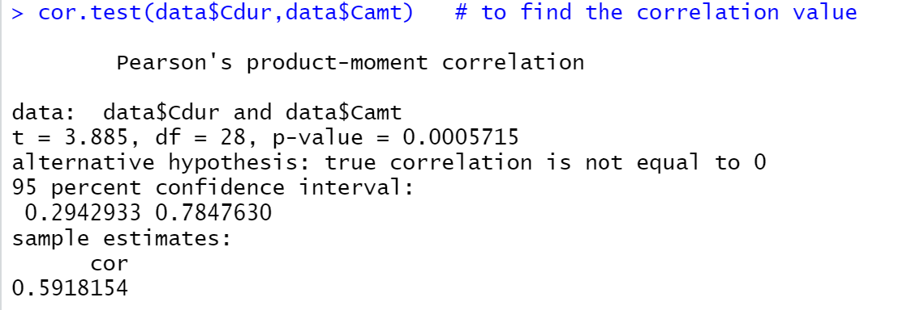

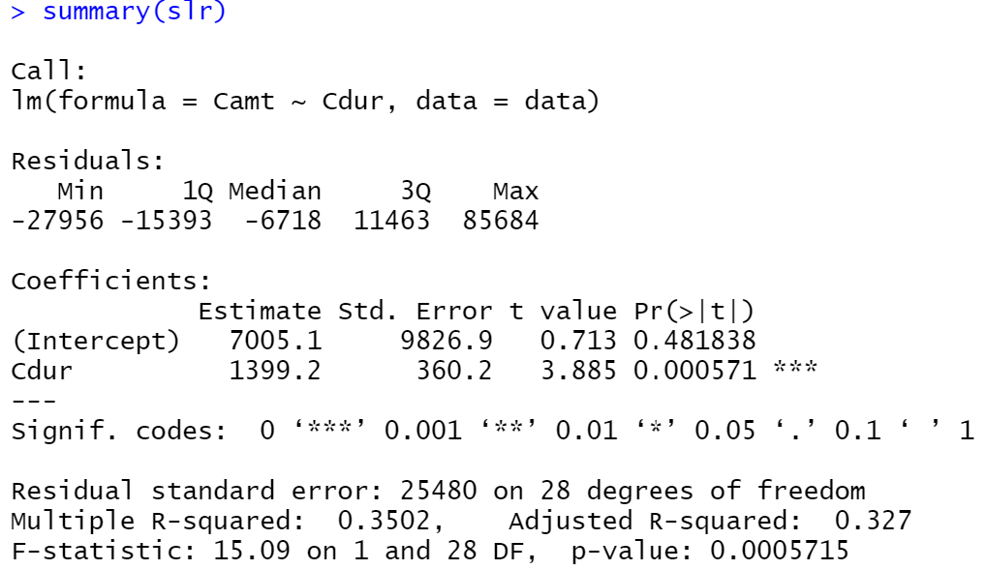

**Residual plot**

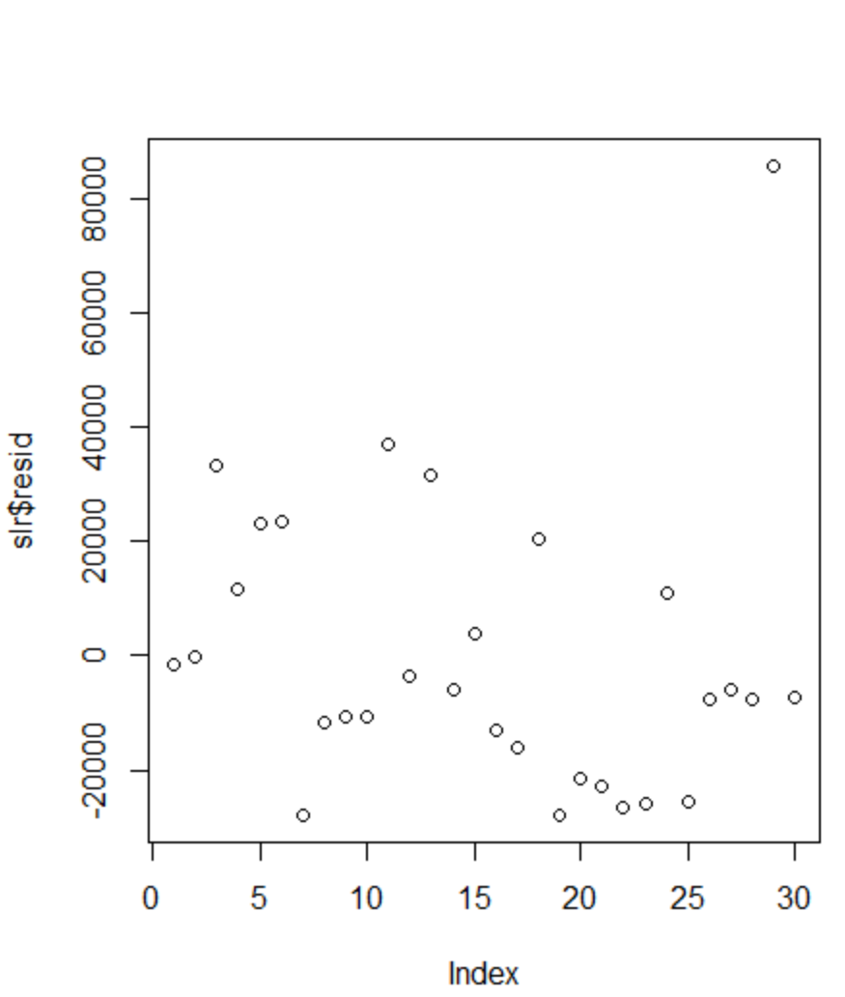

**Q-Q Plot**

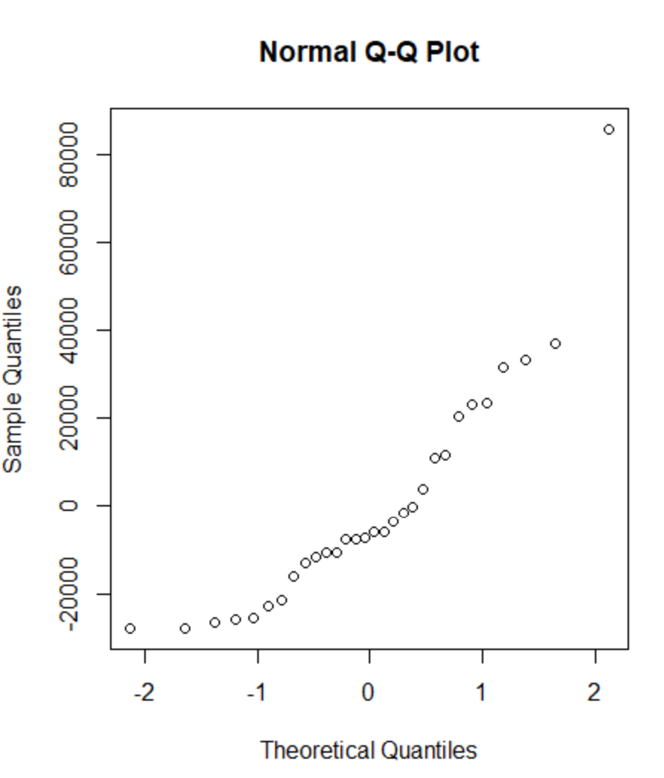

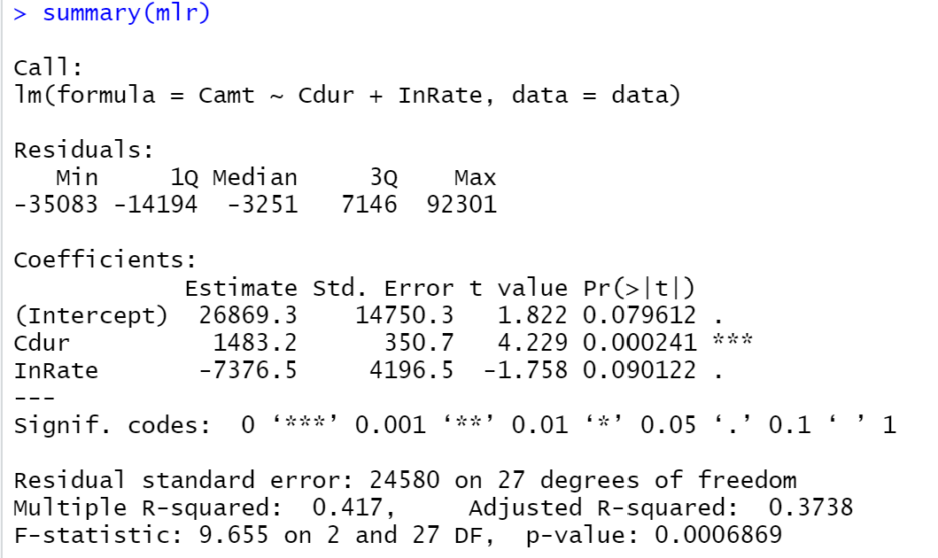

**Residual Plot**

